JEST TEST  
front end   
__tests__/sample.test.ts

PASS __tests__/Button.test.tsx

PASS components/__tests__/TabBarBackground.test.tsx

PASS components/__tests__/IconSymbol.test.tsx

Snapshot Summary

› 1 snapshot file obsolete from 1 test suite. To remove it, press `u`.

↳ • components/__tests__/__snapshots__/ThemedText-test.tsx.snap

PASS __tests__/sample.test.ts

PASS __tests__/Button.test.tsx

PASS components/__tests__/TabBarBackground.test.tsx

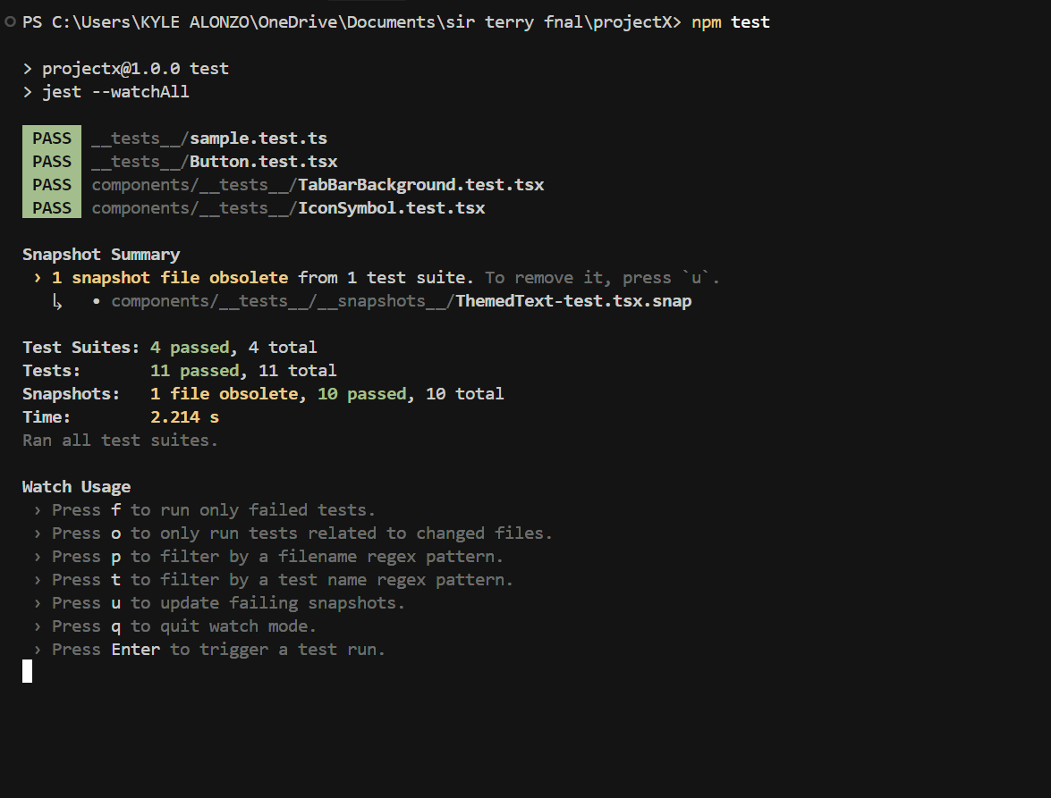 PASS components/__tests__/IconSymbol.test.tsx